**Updated by David Schuftan on 11/19/21**

**\*\*\*\*\*\*\*\*\*\*\*\*\*\*\*\*\*↓ This step is only needed the first time running the code↓\*\*\*\*\*\*\*\*\*\*\*\*\*\*\*\*\*\*\*\*\*\*\*\*\*\***

**Setting Java Path**

Used Codes:

1. setJavaPath.m

Other Needed Files

1. bioformats_package.jar

🡪 This is found in the “bfmatlab.m” folder which can be downloaded at <https://www.openmicroscopy.org/bio-formats/downloads/> and downloading the MATLAB toolbox.

Steps:

1. Run the function “setJavaPath.m”.
2. Navigate to the “bfmatlab.m” folder and select the “bioformats_package.jar”

**\*\*\*\*\*\*\*\*\*\*\*\*\*\*\*\*\*↑This step is only needed the first time running the code↑\*\*\*\*\*\*\*\*\*\*\*\*\*\*\*\*\*\*\*\*\*\*\*\*\*\***

**Convert Files from .nd2 to .mat**

Used Codes:

1. CMOSconverter#_Auto.m

***“#” will refer to current iteration***

Called Functions:

1. bfGetReader.m
2. bfCheckJavaMemory.m
3. bfCheckJavaPath.m
4. bfGetPlane.m
5. is_octave.m

* These are all in the “bfmatlab.m” folder. Make sure to add the folder to the MATLAB path before running.

Other Needed Files

1. bioformats_package.jar

Toolboxes:

1. Image Processing Toolbox

Steps:

1. Run the function “CMOSconverter#_Auto.m” using the call: CMOSconverter#_Auto(fdim1,fdim2,sigma,ngauss,scale,upperframelimit,inputfreq,drawbounds);

***The “#” will refer to current iteration number.

* 1. fdim1: Dimension 1 of median and Gaussian filter neighborhood size. (fdim1 = 3 is originally used)
  2. fdim2: Dimension 2 of median and Gaussian filter neighborhood size. (fdim2 = 3 is originally used)
  3. sigma: Standard Deviation used in Gaussian filtering. (sigma = 0.5 originally used)
  4. ngauss: Number of iterative Gaussian steps applied (ngauss = 2 originally used)
  5. scale: Amount to scale (or bin) the image. (scale = 1 originally used)
  6. upperframelimit: Maximum time steps allowed. Use to crop file for shorter length. To avoid losing data, set upperframelimit value to be larger than the number of time steps in original video.
  7. Inputfreq: The frame/second of camera acquisition settings. Set to ‘auto’ to pull framerate from metadata. Set to integer framerate value to manually input frame rate value. If the ‘auto’ is used and framerate cannot be found, an error will be thrown “Unable to Find Exposure Time for [filename]” and it is recommended that the openmicroscopy files are updated.
  8. drawbounds: Boolean value asking whether to draw bounds to select an ROI.

(drawbounds = 1 🡪 Select ROI; drawbounds = 0 🡪 Use entire frame)

1. Find and select the file(s) that you would like to convert.
   1. If drawbounds = 1
      1. A dialogue box will open asking for the number of ROI to be drawn. To use entire frame input 0. To draw a ROIs, input the number of ROIs that are desired.
      2. A dialogue box will open prompting user to “Use pan and zoom to find desired ROI. Click “OK” when done.” Use this time to locate the desired ROI in the screen and then click “OK”.
      3. After clicking “OK” ROIs can now be drawn on the image by clicking and holding the cursor and tracing the ROI. If more ROI are to be drawn, repeat steps 3.a.ii and 3.a.iii.
   2. If drawbounds = 0
      1. Continue to step 4.
2. .mat version of the files will now have been made in the same location as the original .nd2 file. If multiple ROI are drawn, multiple files will be made with indexed values at the end of the file name referring to the specific ROI number.

**\*\*\*\*\*\*\*\*\*\*\*\*\*\*\*To use all of the below codes, the videos must first be converted from .nd2 files to .mat files using the CMOSconverter#_Auto.m code described above.\*\*\*\*\*\*\*\*\*\*\*\*\*\*\*\*\*\*\*\*\*\*\*\*\*\*\*\*\*\*\*\*\*\*\*\*\*\*\*\*\*\*\***

**Analyzing Voltage Dynamics (Berst)**

Used Codes:

1. apd_time_avg_separate#.m”

***“#” will refer to current iteration***

Called Functions:

1. backcor.m

Toolboxes:

1. Signal Processing Toolbox

Steps:

1. Open and run the file “apd_time_avg_separate#.m” where the “#” will refer to current iteration number.
   1. The default inputs are ‘method = “amp”’ and ‘num = “20”’, but to change this to a different amplitude or derivative method call the function using apd_time_avg_separate#(“method”,”num”) where method is the method (“amp” or “deriv”) and the num is the value of the method (% amplitude or order of derivative). These inputs will be used to determine the start of the AP upstroke.
      1. “amp” uses the point when the trace reaches “num” % of the height of the individual AP spike.
      2. “deriv” finds the maximum of the “num” derivative before the AP peak.
2. Select the .mat file(s) of the berst videos to be analyzed.
3. When all the videos have been analyzed, the figure with marked points will be generated and new folders for each individual video will be created in the directory where the figure is saved as well as files for the output data, the background, the corrected trace, and the original trace. Additionally, a folder titled “APD Data” will be created in the directory. This will house all of the data from any files analyzed in the directory. There will also be an Excel sheet in the “APD Data” folder with all of the output data.
   1. Note that for each run, all of the output .m files in the “APD Data” folder will be tabulated into the Excel sheet whether that file was analyzed on that run or not.
   2. If the program is unable to process a file due to arrythmia, non-beating, or other errors, “Unable to Fully Process file [filename]” will be printed to the Command Window. A figure with the raw data will be printed and saved with the word “nul” at the start and the row on the excel sheet for that video will have empty data values.

Outputs:

1. Amp (Amplitude): The average BeRST RFU intensity of the AP peaks after background correction.
2. APD30 (Action Potential Duration 30): The average time from the start of the upstroke to when the signal has repolarized 30%. (i.e., when the signal is at 70% of the maximum amplitude after reaching the peak.)
3. APD50 (Action Potential Duration 50): The average time from the start of the upstroke to when the signal has repolarized 50%. (i.e., when the signal is at 50% of the maximum amplitude after reaching the peak.)
4. APD80 (Action Potential Duration 80): The average time from the start of the upstroke to when the signal has repolarized 80%. (i.e., when the signal is at 20% of the maximum amplitude after reaching the peak.)
5. APD90 (Action Potential Duration 90): The average time from the start of the upstroke to when the signal has repolarized 90%. (i.e., when the signal is at 10% of the maximum amplitude after reaching the peak.)
6. UPD (Upstroke Duration): The time from the start of the upstroke to the peak.
7. Total Width: The average total width of the action potential. Measured from the minimum-to-minimum value on each side of every peak.
8. BPM (Beats per minute): Number of peaks found divided by time between first and last peak.
9. delF_f0 (ΔF/f0): The value of Amp divided by the value of the removed background at the start of the first AP.
10. f0: Value of the removed background at the start of the first AP.
11. DVDT (dV/dt): The average maximum change in RFU intensity over a time step between the start of the upstroke and the peak.
12. PeakTime: The average amount of time that the AP peaks are above 80% of the maximum amplitude of the.

*** These are average values of each individual AP in the trace.

***The _std is the standard deviation of the values generated from each individual AP in the trace.

***The COR outputs are the same as the above outputs corrected for beat rate using Fridericia’s formula.

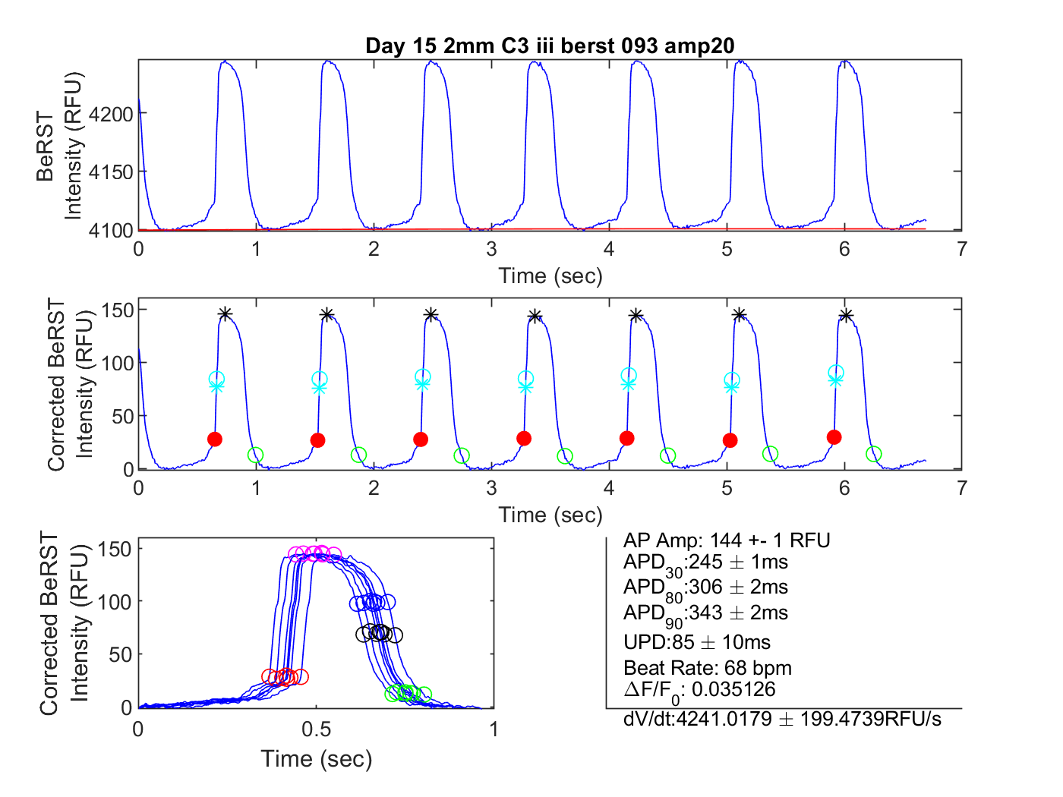

Start of Upstroke

Maximum amplitude of AP

APD90 endpoint

dV/dt is between these two points

**Analyzing Calcium Dynamics (gcamp/gfp)**

Used Codes:

1. Calcium_time_avg_separate#.m”

***“#” will refer to current iteration***

Called Functions:

1. backcor.m

Toolboxes:

1. Signal Processing Toolbox

Steps:

1. Open and run the file “calcium_time_avg_separate#.m” where the “#” will refer to current iteration number..
   1. The default inputs are ‘method = “amp”’ and ‘num = “5”’, but to change this to a different amplitude or derivative method call the function using apd_time_avg_separate#(“method”,”num”) where method is the method (“amp” or “deriv”) and the num is the value of the method (% amplitude or order of derivative). These inputs will be used to determine the start of the AP upstroke.
      1. “amp” uses the point when the trace reaches “num” % of the height of the individual calcium spike.
      2. “deriv” finds the maximum of the “num” derivative before the calcium peak.
2. Select the .mat file(s) of the calcium videos to be analyzed.
3. When all the videos have been analyzed, the figure with marked points will be generated and new folders for each individual video will be created in the directory where the figure is saved as well as files for the output data, the background, the corrected trace, and the original trace. Additionally, a folder titled “CAL Data” will be created in the directory. This will house all of the data from any files analyzed in the directory. There will also be an Excel sheet in the “CAL Data” folder with all of the output data.
   1. Note that for each run, all of the output .m files in the “CAL Data” folder will be tabulated into the Excel sheet whether that file was analyzed on that run or not.
   2. If the program is unable to process a file due to arrythmia, non-beating, or other errors, “Unable to Fully Process file [filename]” will be printed to the Command Window. A figure with the raw data will be printed and saved with the word “nul” at the start and the row on the excel sheet for that video will have empty data values.

Outputs:

1. Ca_Amp (Amplitude): The average GCaMP6f RFU intensity of the CAL peaks after background correction.
2. Decay30 (Calcium Decay 30): The average time from the peak to when the signal has decayed 30%. (i.e., when the signal is at 70% of the maximum amplitude after reaching the peak.)
3. Decay50 (Calcium Decay 50): The average time from the peak to when the signal has decayed 50%. (i.e., when the signal is at 50% of the maximum amplitude after reaching the peak.)
4. Decay75 (Calcium Decay 80): The average time from the peak to when the signal has decayed 75%. (i.e., when the signal is at 25% of the maximum amplitude after reaching the peak.)
5. UPD (Upstroke Duration): The time from the start of the upstroke to the peak.
6. BPM (Beats per minute): Number of peaks found divided by time between first and last peak.
7. Total Width: The average total width of the action potential. Measured from the minimum-to-minimum value on each side of every peak.
8. AUC (Area under the Curve): Integration of the area under the curve from the start of the upstroke to point where the signal has decayed 75%.
9. delF_f0 (ΔF/f0): The value of Amp divided by the value of the removed background at the start of the first AP.
10. f0: Value of the removed background at the start of the first AP.
11. DCADT (dV/dt): The average maximum change in RFU intensity over a time step between the start of the upstroke and the peak.
12. PeakTime: The average amount of time that the AP peaks are above 80% of the maximum amplitude of the.

*** These are average values of each individual AP in the trace.

***The _std is the standard deviation of the values generated from each individual AP in the trace.

***The COR outputs are the same as the above outputs corrected for beat rate using Fridericia’s formula.

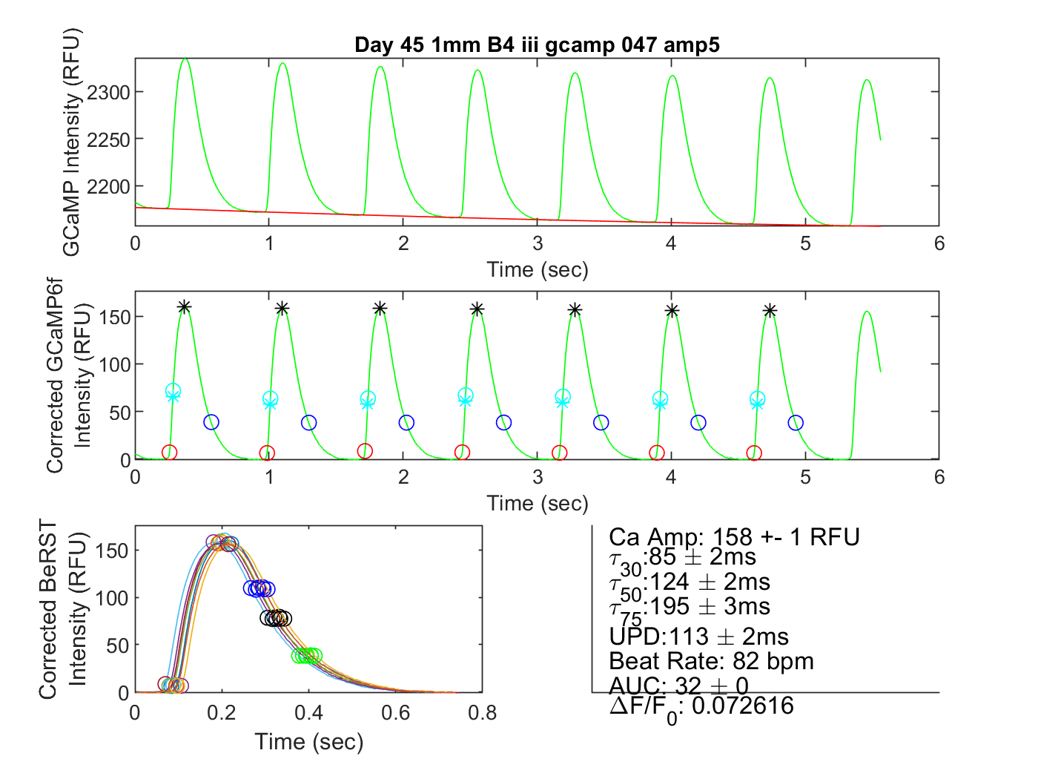

Start of Upstroke

Maximum amplitude of AP

dV/dt is between these two points

Decay75 endpoint